# Project Documentation

# Project Title

1. **Introduction**

**Here’s a sharp intro for InsightStream: Navigate the News Landscape:**

**In a world awash with headlines, InsightStream cuts through the noise—bringing you what matters, when it matters. Seamlessly filtering sources, highlighting trends, and offering context, it’s your guide to understanding today’s global narrative with clarity and depth.**

**If you like, I can tweak it for tone (formal / casual / techy / journalistic) or length**.

**• Project Title:Insightstream navigate and news landscape**

**• Team ID : NM2025TMID44255**

**• Team Leader: Name: M.Priya Email.id:** [**priyamurugan27022007@gmail.com**](mailto:priyamurugan27022007@gmail.com)

**• Team Members:**

**–Name: K.Monica Email id:** [**monica49214@gmail.com**](mailto:monica49214@gmail.com)

**-Name: P.Priyadharshini Email id:** [**dharshini21200@gmail.com**](mailto:dharshini21200@gmail.com)

**Name : N.Sabitha Email id:** [**sabithanagarajan2006@gmail.com**](mailto:sabithanagarajan2006@gmail.com)

1. **Project Overview**

**• Purpose**: SB Works connects clients and freelancers through project postings, bidding, and real-time communication.

**• Features:**

– Project posting and bidding

– Secure chat system

– Feedback and review system

– Admin control panel

1. **Architecture**

• **Frontend**: React.js with Bootstrap and Material UI

• **Backend**: Node.js and Express.js managing server logic and API endpoints

**• Database**: MongoDB stores user data, project information, applications, and chat messages

1. **Setup Instructions**

**• Prerequisites**:

– Node.js

– MongoDB

– React.js

– Express.js – Mongoos– Visual Studio Code

• **Installation Steps**:

# Clone the repository git clone

# Install client dependencies cd client npm install

# Install server dependencies cd ../server npm install

1. **Folder Structure**

**Components**

**Homearticles.jsx**

**Hero.jsx**

**Context**

**Generalcontext.jsx**

**Pages**

**Categorypage.jsx**

**Newspage.jsx**

**Styles**

**Footer.css**

**Hero.css**

**Running the Application**

**• Frontend**:

cd client

npm start

**• Backend:**

cd server npm

start

• **Access**: Visit <http://localhost:3000>

1. **API Documentation**

• **User**:

– /api/user/register

– /api/user/login

• **Projects:**

– /api/projects/create

– /api/projects/:id • Applications: /api/apply

• **Chats:**

– /api/chat/send

– /api/chat/:userId

1. **Authentication**

• JWT-based authentication for secure login

• Middleware protects private routes

1. **User Interface**

• Landing Page

• Freelancer Dashboard

• Admin Panel

• Project Details Page

1. **Testing**

• Manual testing during milestones

• Tools: Postman, Chrome Dev Tools

**11. Screenshots or Demo**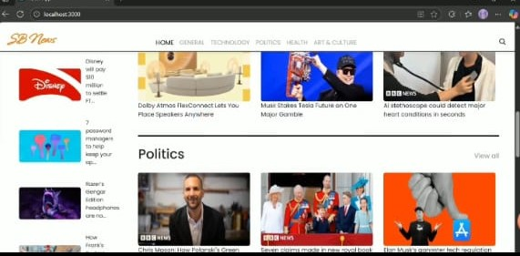

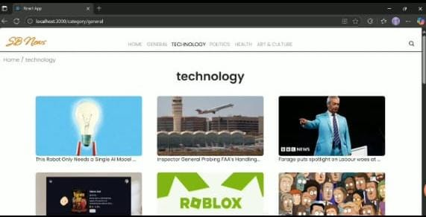

**12. Known Issues**

**13. Future Enhancements**